The New Writing Series
presents
Pina Piccolo

WEDNESDAY FEBRUARY 13
4:30pm
Allen and Sally Fernald APPE space
104 Stewart Commons

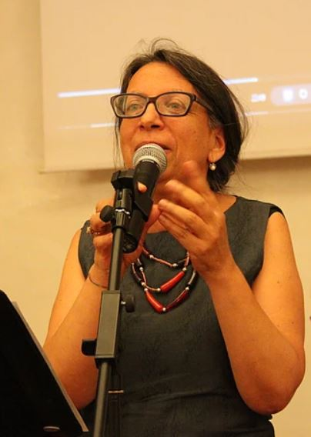

Poetry, Translation, and Global Migration

Documenting through poetry, art performances, and video essays
the global migration crisis across the Mediterranean

Pina Piccolo is a poet, translator, and independent, scholar born in California and educated at Berkeley (Ph.D. Italian Literature). She moved to Italy in 2003, where she participated in the creation of La Macchina Sognante: Contenitore delle Scritture del Mondo, an online journal of literature and culture that presents marginal and dissident writing from across the world. She is presently the coordinator and curator of the English language version of the journal, The Dreaming Machine. Her poems have appeared in anthologies in Italy and the U.S., including Rondini e ronde—scritti migranti per volare sul razzismo (Mangrovie Edizioni 2010), Cuore di preda (CFR Edizioni, 2013), Sotto il cielo di Lampedusa, I and II (Rayuela 2013, 2014). Her scholarly essays on Dario Fo and Franca Rame have appeared in Italica and Forum Italicum, while her essays on Gianni Celati and Luigi di Ruscio have appeared in Gradiva, Italian Quarterly and the American Journal of Italian Studies. Her collection of poems I canti dell’Interregno was published in Italy by Lebeg Edizioni in 2018. She blogs at http://www.pinapiccolosblog.com/

This event is free and open to the public.

